**S3 Project**

**Scenario**

Your company wants to distribute their content in the form of a website to their global offices. However, due to some legal restrictions, you cannot distribute the content in France and Australia. You need to find a way to prevent these offices from accessing the data.

The content does not change very often; however, some of the files are very large, and you have to find a solution to minimize end user latency.

The last requirement is that the audit department wants to track whoever is accessing the website.

1. Create a bucket named **websitesowmya** in S3 to host a website
2. Create a bucket named **mylogbucketsowmya** to store the logs

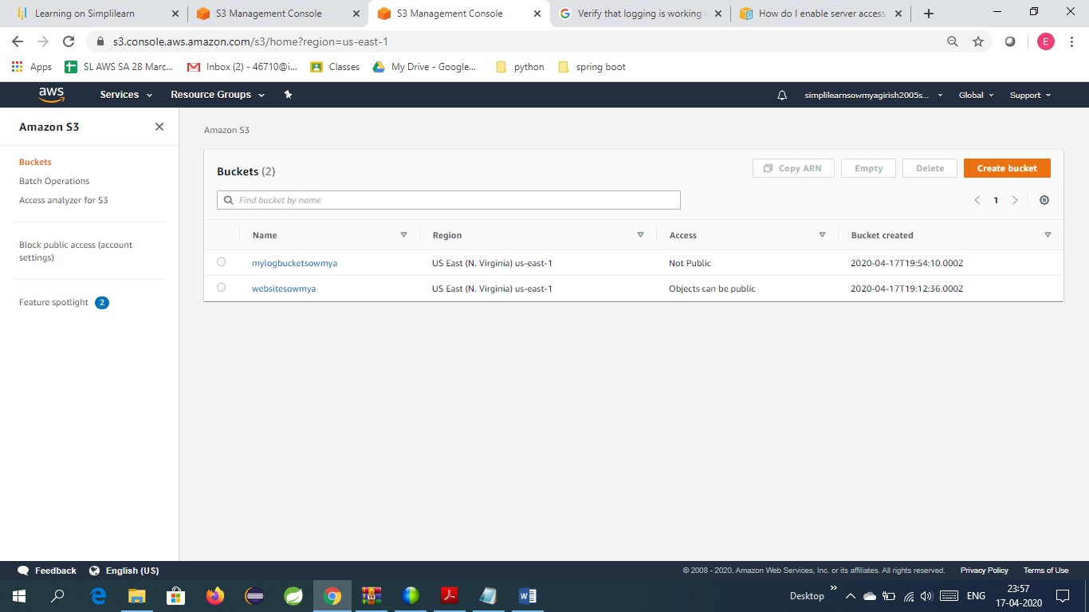

1. Upload index.html file into the bucket

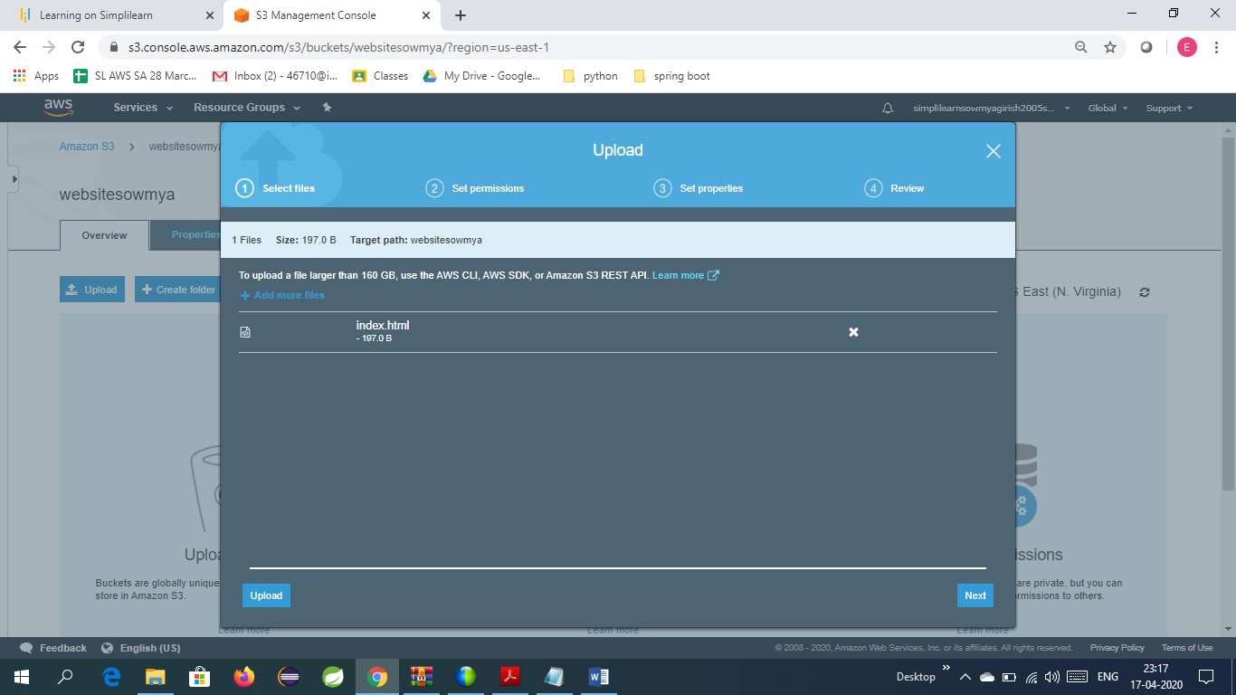

1. Enable logging and versioning

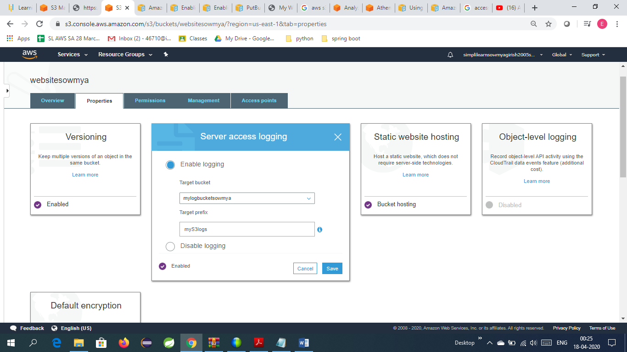

1. Enable static website hosting

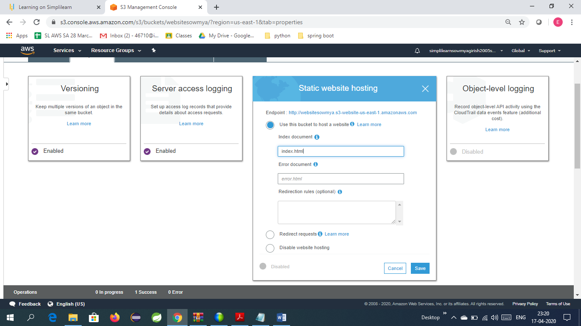

1. Click on Make Public button to access through end point

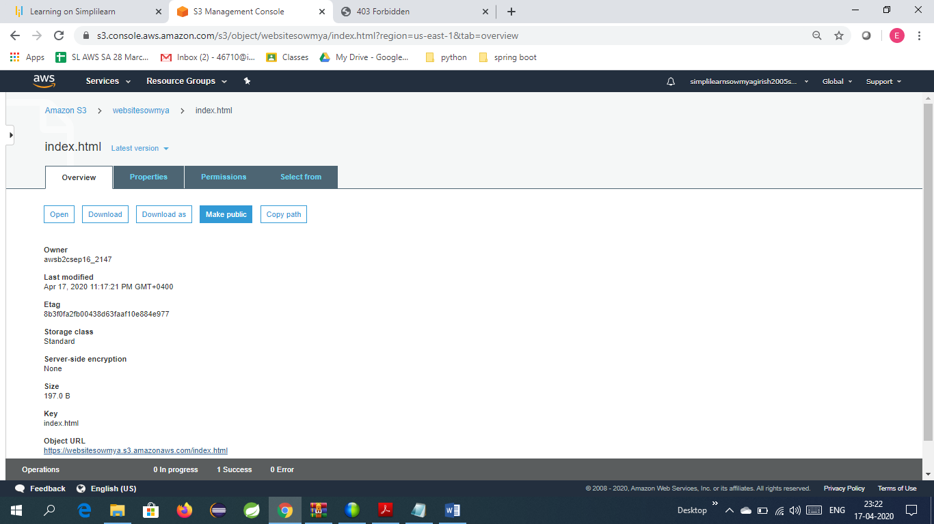

1. Website is now accessible

Url is <http://websitesowmya.s3-website-us-east-1.amazonaws.com/>

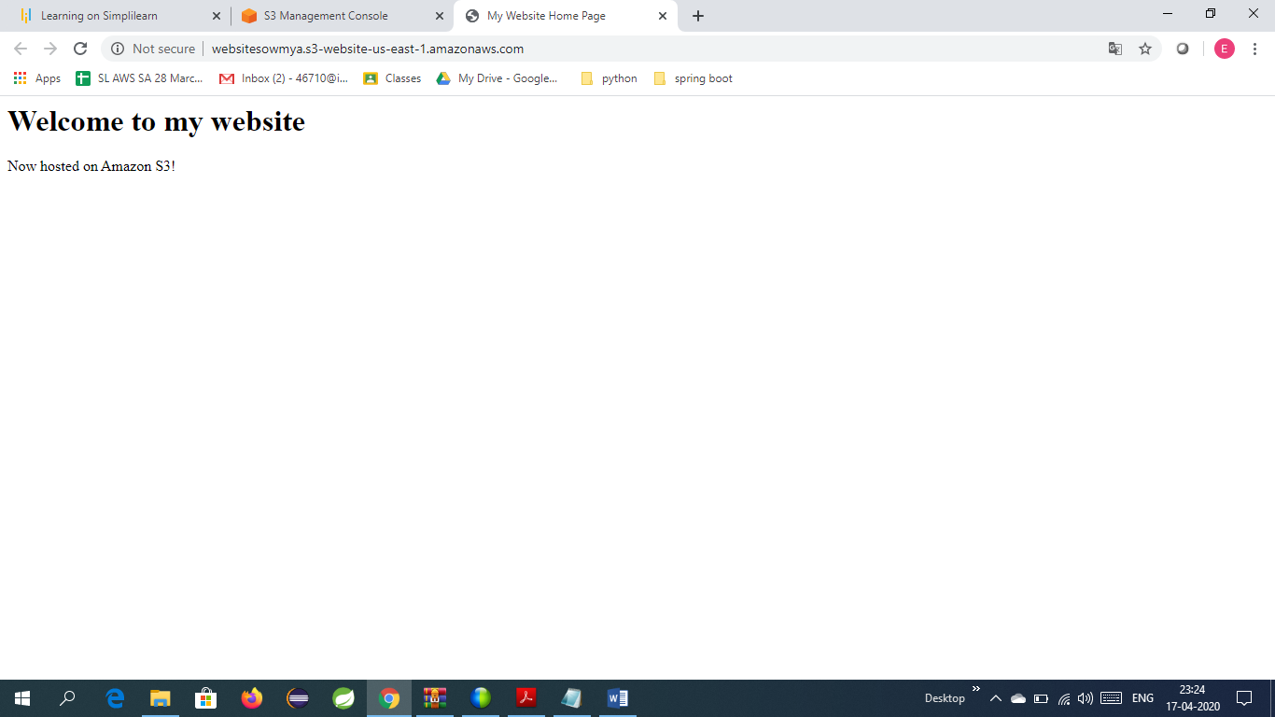

1. Create CloudFront Distribution for the S3 bucket

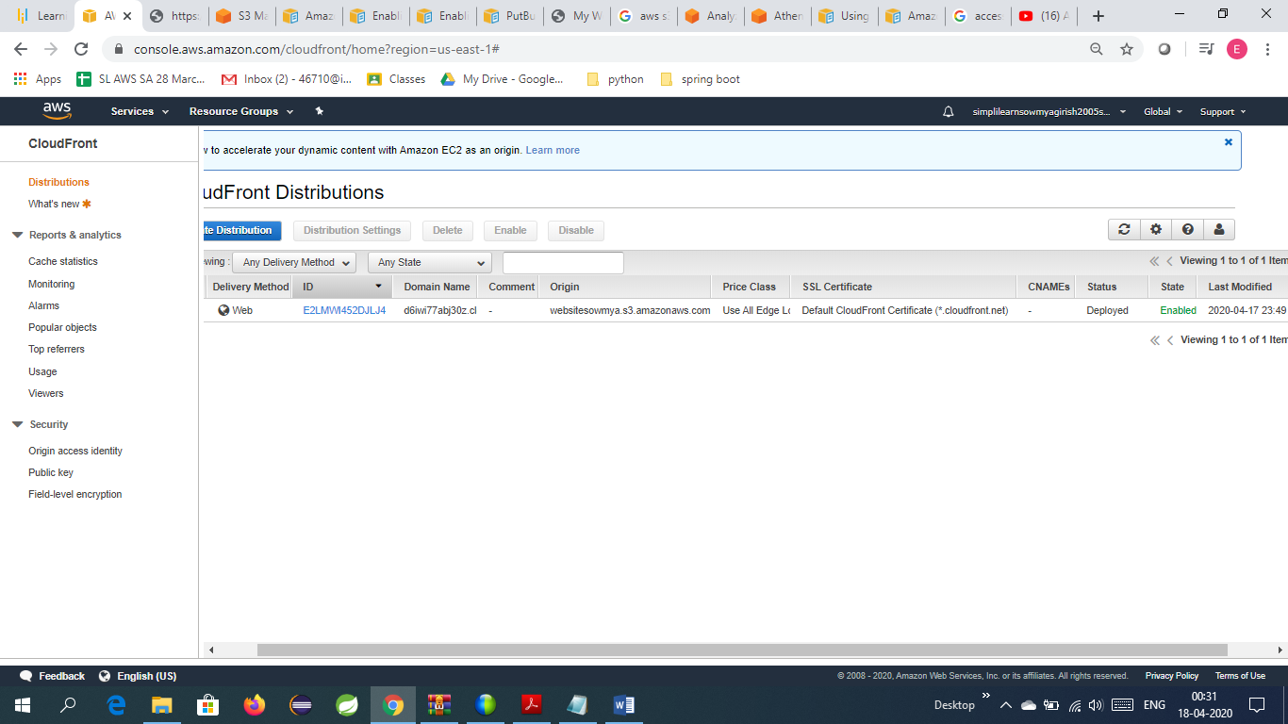

1. Click on the ID E2LMWI452DJLJ4

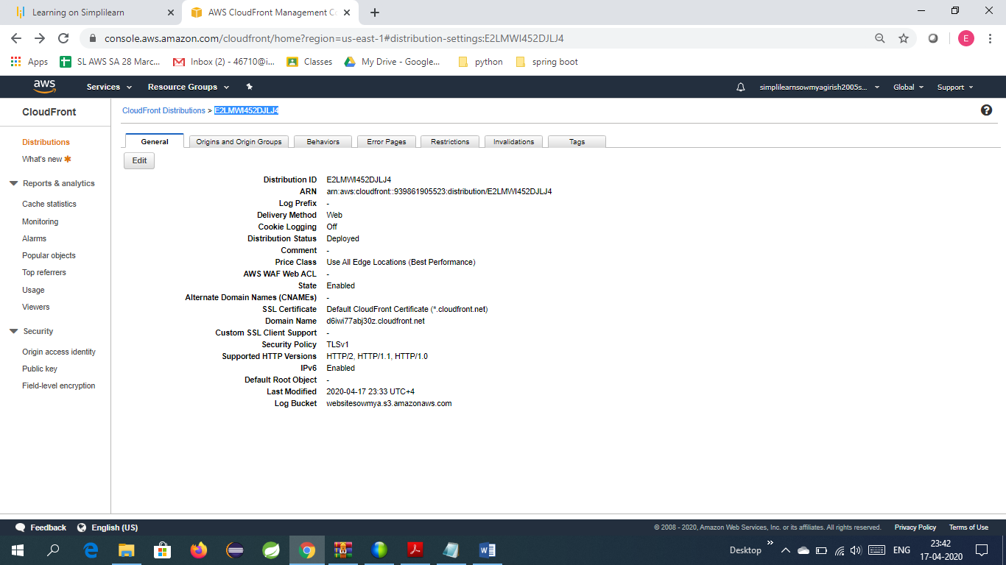

1. Edit the Restrictions Tab to blacklist France and Austrailia

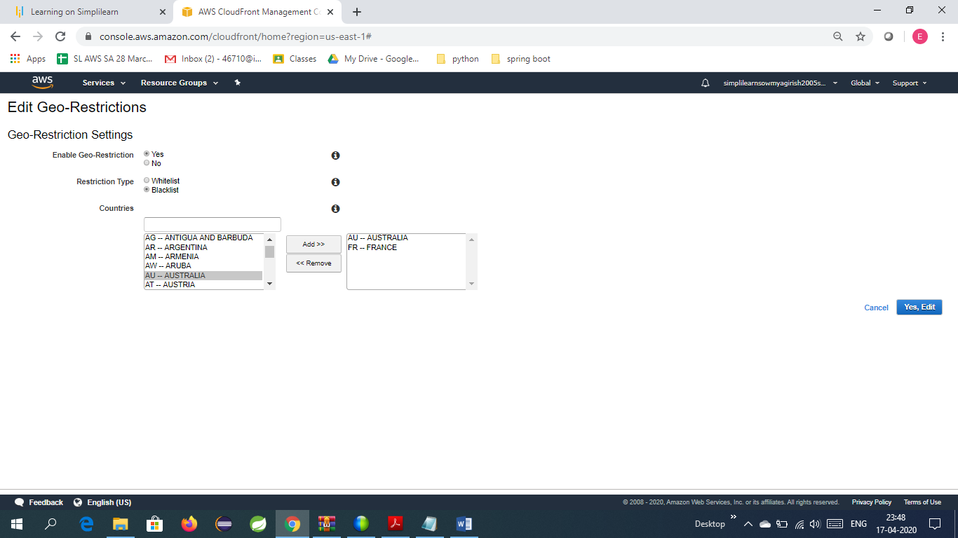

1. Logs can be accessed in mylogbucketsowmya

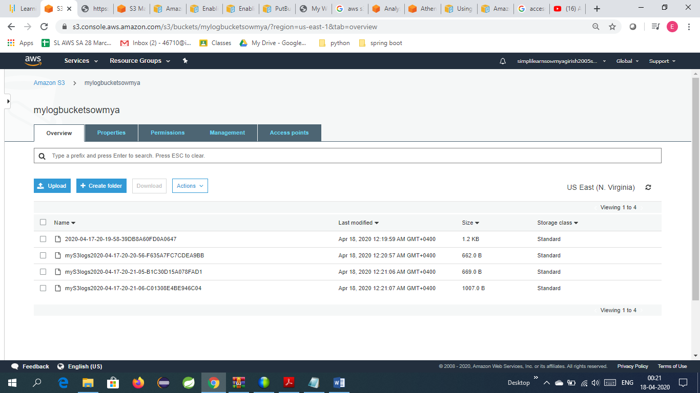

Now the audit department can track whoever is accessing the website.